EADS NA Defense

Software Design Document

Digital Oscilloscope XML to IVI driver for the ZTEC 1428VXI
XmlDriver – AtXmlZT1428VXI.dll

SDD- AtXmlZT1428VXI
Version 0.00
12 December 2005

This document and the information contained herein are proprietary to EADS NA Defense and may not be disclosed in whole or in part to any parties without the expressed written consent of EADS NA Defense.

© EADS NA Defense
1222 Lucas Ave. Suite 200
St. Louis MO 63103
phone (314) 727 1337
fax (314) 727 6750

Software Design Document

Version 0.00

History of changes
9/15/05 Preliminary
Change Table

Change | Date | Paragraph

1 Scope 5
1.1 Identification 5
1.2 System Overview 5
1.3 Document Overview 5
2 Reference Documents 5
3 System-Wide Design Overview 5
3.1 Assumptions and Dependencies 5
3.2 General Constraints 6
3.3 Goals and Guidelines. 6
3.4 Safety and Security Considerations 6
3.5 Development Methods 6
4 System Architectural Design 7
4.1 System Components 7
4.2 Interface design 8
4.2.1 Common Interface (AtXmlZT1428VXI.cpp) 8
4.2.2 Per Instrument Instance (AtXmlZT1428VXI_T.cpp) 9
5 Detailed Design 10
5.1 Classification 10
5.2 XML Attribute Definition 11
5.3 Instrument IDs 18
5.4 Generic Measurement Definition 18
5.5 Digital Scope Programming Specifications 19
5.5.1 Programming Resolution 19
5.5.2 Programming Accuracy 19
5.6 Processing 19
6 Notes 19
6.1 IEEE1641 XML / Instrument Control Examples 19
6.1.1 DC Signal Voltage Measurement 19

Scope

Identification
The software configuration component AtXmlZT1428VXI.dll provides the software routines necessary to control the TETS Analog System DSO/DigitalScope the ZT1428VXI.

System Overview
The TETS CICL provides a TE Interface to permit the TPS/TE to send XML signal descriptions to the test system instruments. Each instrument manufacturer provides an IVI/PnP API to control the instrument. The module defined herein provides the control of the ZT1428VXI by processing the XML signal descriptions into manufacturer API calls. The AtXmlZT1428VXI.dll accepts the TETS CICL TE Interface XML signal descriptions that describes the action and signal modifiers described in IEEE1641 XML Test Signal Framework (TSF) Library and Basic Signal Component (BCS) layer descriptions. The TSF signal descriptions are mapped to the BSC component layer via the TSF Library as per the IEEEE1641 specification. The resultant BSC component descriptions are processed to control the instrument via the IVI/PnP API. In addition to the standard BSC sensor functionality, the standard provides for the use of “Generic Measurements”.

In addition to the XML interface, several standard TETS CICL interface functions are also provided for status, station calibration data (e.g. Path Loss Compensation (PLC)), and low level control.

Document Overview
This document defines the detailed software design for the TETS XML driver for the ZT1428VXI. The value ranges of all the IEEE1641 BSC attributes and how they are used to control the ZT1428VXI are also specified within. This document provides a detailed definition of the “Generic Measurements” implemented. This document provides a detailed description of the standard TETS CICL functions

Reference Documents
- DEFCOT&S-3560-SDD-001 CICL Software for TETS Software Detailed Design

System-Wide Design Overview
The TETS CICL provides a TE Interface that supports XML signal descriptions (i.e. IEEE1641 TSF/BSC). These signal descriptions are passed directly to this XML to IVI processor. In addition the TETS CICL requires direct access to status, calibration data, and low level control features of the instrument.

Assumptions and Dependencies
The following assumptions and dependencies are made:
- The TETS signal descriptions will conform to the IEEE1641 standard TSF/BSC definitions.
- When “Generic Measurements” are used, the TETS signal descriptions will only use “Generic Measurements” specified in this document.
- The full instrument range will be implemented when they exceed the ranges in the system requirements specification.
- The full functionality of the instrument will be implemented to the extent possible where the XML mapping can be defined. (Detailed below).

General Constraints
The sections below will detail which of the IEEE 1641 BSC attributes are used and how they are used to control the ZT1428VXI. The sections below will detail which “Generic Measurements” are allowed and details of how the measurement is taken.

Goals and Guidelines.
- Implement the full range and functionality as can be supported by the TETS XML signal description.

Safety and Security Considerations
No safety or security considerations for this module.

Development Methods
As described in the “TETS XML Driver Software Development Style Guide”

System Architectural Design
The TETS XML Driver provides an TETS specific common interface for each instrument. A common set of interfaces are provided to provide the instrument’s operation within the TETS Architeture. (See the “EADS XML Driver Software Development Style Guide” for details). The essence of the XML driver is defined as a class CZT1428VXI. When multiple instruments (ZT1428VXIs) are available in the station, an instance of the CZT1428VXI class will be instantiated. Therefore, the member variables and methods need only control a single instrument.
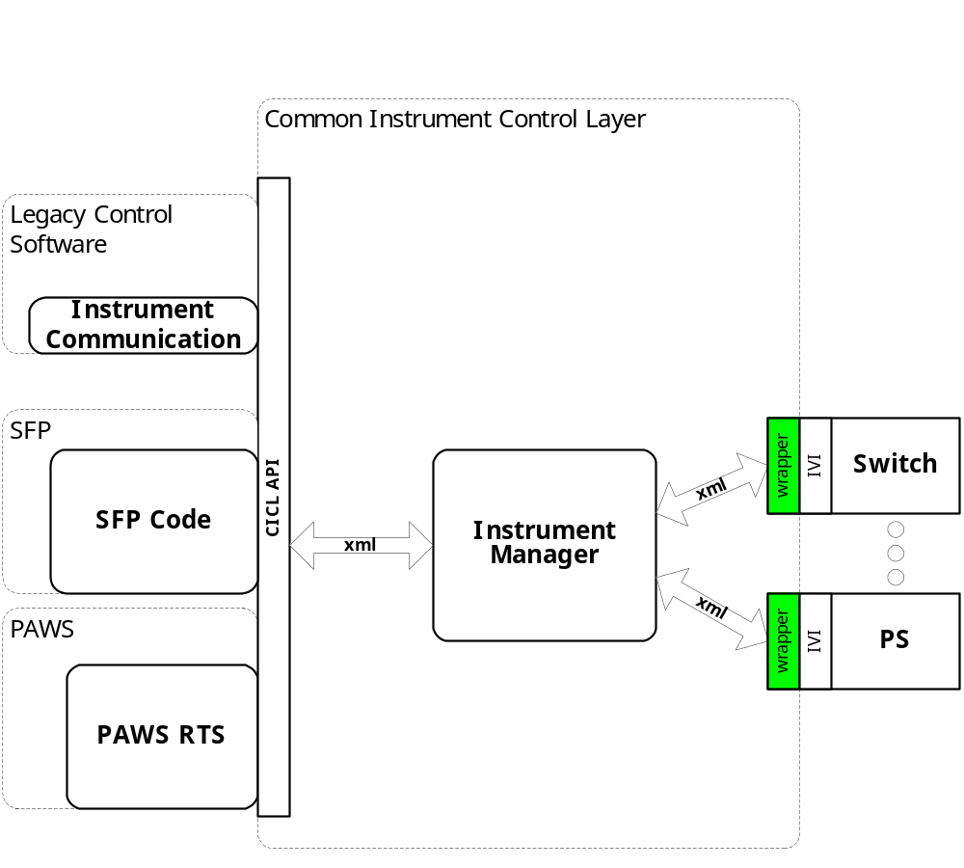
Figure 4.0 XML Driver Function Relationships

System Components
The XML driver will consist of:
- A Microsoft Visual C++ project to build the .dll
  - TETS XML standard interface functions
    - AtXmlZT1428VXI.cpp
  - Configuration Information
  - AtXmlZT1428VXI.rc
  - resource.h
  - The instrument specific driver file AtXmlZT1428VXI_T.cpp

Interface design

Common Interface (AtXmlZT1428VXI.cpp)

Function | Purpose
Initialize(int instno, char* instid, bool sim, int dbglvl, int prime_addr, int second_addr, int sub_mod_addr, CICL_XML_String* Response, int BufferSize) | This function is used to initialize the instrument, register the system assigned “instno” to the “Instid” (InstDrvrComponentID), obtain instrument availability status, and establish the device is in simulation mode and / or debug. This call may be issued multiple times to clear the instrument interface and alter the simulation mode or debug level.
Close(void) | This function shuts down the instrument and releases the device from active use status.
IssueSignal(int instno, CICL_XML_Snippet* SignalDescription, CICL_XML_String* Response, int BufferSize) | This function accepts the XML signal description, processes it, and returns a response
IssueNativeCmds(CICL_XML_String* InstrumentCommands, CICL_XML_String* Response, int BufferSize) | This function accepts the XML string that contains an instno, and a native instrument command string. It processes it, and returns a response
IssueDriverFunctionCall(int instno, CICL_XML_String* DriverFunction, CICL_XML_String* Response, int BufferSize) | This function accepts the XML string that contains a native instrument driver function call, processes it, and returns a response
Status(int instno, CICL_XML_String* Response, int BufferSize) | This function queries the instrument for status and returns the status and any errors to the SC
RegCal(int instno, CICL_XML_String* CalData) | This function registers the provided calibration data (e.g. PLC data) for use by the instrument driver
RegisterTSF(CICL_XML_Filename* TSFSignalDefinition, CICL_XML_Filename* TSFLibrary, CICL_XML_Filename* STDTSF, CICL_XML_Filename* STDBSC) | This function registers the TSF library data for this device
Reset(int instno, CICL_XML_String* Response, int BufferSize) | This function is responsible for resetting the instrument. The “instno” 0 will be reserved for a RESETALL action and shall reset all the instrument instances initialized.
Ist(int instno, int Level, CICL_XML_String* Response, int BufferSize) | This function is responsible for performing the instrument built in self test. It returns the instrument status. Where Level:  CICL_IST_LVL_CNF  CICL_IST_LVL_IST  CICL_IST_LVL_BIT1 - …BIT5

Per Instrument Instance (AtXmlZT1428VXI_T.cpp)

Function | Purpose
CZT1428VXI(bool sim, int dbglvl, int prime_addr, int second_addr) | This function is used to initialize the instrument, obtain instrument availability status, and establish if the device is in simulation mode and / or debug.
~CZT1428VXI(void) | This function shuts down the instrument and releases the device from active use status.
SetupZT1428VXI(CICL_XML_Snippet* SignalDescription, CICL_XML_String* Response, int BufferSize) | This function is the entry point for the setup action. The Signal Description is the BSC XML produced by expanding the TSF Library definitions
StatusZT1428VXI(CICL_XML_Snippet* SignalDescription, CICL_XML_String* Response, int BufferSize) | This function is the entry point for the status action. The Signal Description is the BSC XML produced by expanding the TSF Library definitions
FetchZT1428VXI(CICL_XML_Snippet* SignalDescription, CICL_XML_String* Response, int BufferSize) | This function is the entry point for the fetch action. The Signal Description is the BSC XML produced by expanding the TSF Library definitions
InitiateZT1428VXI(CICL_XML_Snippet* SignalDescription, CICL_XML_String* Response, int BufferSize) | This function is the entry point for the initiate action. The Signal Description is the BSC XML produced by expanding the TSF Library definitions
ResetZT1428VXI(CICL_XML_Snippet* SignalDescription, CICL_XML_String* Response, int BufferSize) | This function is the entry point for the reset action. The Signal Description is the BSC XML produced by expanding the TSF Library definitions.
CloseZT1428VXI(CICL_XML_Snippet* SignalDescription, CICL_XML_String* Response, int BufferSize) | This function is the entry point for the close action. The Signal Description is the BSC XML produced by expanding the TSF Library definitions.
OpenZT1428VXI(CICL_XML_Snippet* SignalDescription, CICL_XML_String* Response, int BufferSize) | This function is the entry point for the open action. The Signal Description is the BSC XML produced by expanding the TSF Library definitions.
SendNativeCmds(CICL_XML_String* InstrumentCommands, CICL_XML_String* Response, int BufferSize) | This function accepts the XML string that contains a native instrument command string, processes it, and returns a response
DoDriverFunctionCall(CICL_XML_String* DriverFunction, CICL_XML_String* Response, int BufferSize) | This function accepts the XML string that contains a native instrument driver function call, processes it, and returns a response

Detailed Design

Classification
This module is unclassified.

Instrument IDs
The following list defines the accepted Instrument IDs for the ZT1428VXI:
- DSO_ZT1428VXI – Digital Scope functionality

Generic Measurement Definition
The following table specifies the IEEE 1641 Generic Measurement attributes used to control the ZT1428VXI:

Modifier | Dim | Value Range | Description
acs_volt | V |  | AC RMS Voltage
acs_vlpk | V |  | AC Peak Voltage
acs_vlpp | V |  | AC Peak to Peak Voltage
acs_freq | Hz |  | AC Frequency
acs_peri | s |  | AC Period
acs_valv | V |  | AC Average Voltage
dcs_volt | V |  | DC Voltage
pdc_vlpk | V |  | Pulsed DC Peak Voltage
pdc_prfr | Hz |  | Pulsed DC PRF
pdc_peri | s |  | Pulsed DC Period
pdc_rise | s |  | Pulsed DC Rise Time
pdc_fall | s |  | Pulsed DC Fall Time
pdc_plwd | s |  | Pulsed DC Pulse Width
pdc_duty | pc |  | Pulsed DC Duty Cycle
pdc_psht | pc |  | Pulsed DC Preshoot
pdc_over | pc |  | Pulsed DC Overshoot
pdc_vlpp | V |  | Pulsed DC Peak to Peak Voltage
pdc_vpkp | V |  | Pulsed DC Voltage Peak Positive
pdc_vpkn | V |  | Pulsed DC Voltage Peak Negative
pdc_ppwt | s |  | Pulsed DC Positive Pulse Width
pdc_npwt | s |  | Pulsed DC Negative Pulse Width
sqw_vlpk | V |  | Square Wave Peak Voltage
sqw_vlpp | V |  | Square Wave Peak to Peak Voltage
sqw_vpkp | V |  | Square Wave Voltage Peak Positve
sqw_vpkn | V |  | Square Wave Voltage Peak Negative
sqw_freq | Hz |  | Square Wave Frequency
sqw_peri | s |  | Square Wave Period
sqw_rise | s |  | Square Wave Rise Time
sqw_fall | s |  | Square Wave Fall Time
sqw_duty | pc |  | Square Wave Duty Cycle
rps_vlpk | V |  | Ramp Signal Peak Voltage
rps_vlpp | V |  | Ramp Signal Peak to Peak Voltage
rps_vpkp | V |  | Ramp Signal Voltage Peak Positive
rps_vpkn | V |  | Ramp Signal Voltage Peak Negative
rps_freq | Hz |  | Ramp Signal Frequency
rps_peri | s |  | Ramp Signal Period
rps_rise | s |  | Ramp Signal Rise Time
rps_fall | s |  | Ramp Signal Fall Time
tmi_time | s |  | Time interval between two events
tri_vlpk | V |  | Triangular Wave Peak Voltage
tri_vlpp | V |  | Triangular Wave Peak to Peak Voltage
tri_vpkp | V |  | Triangular Wave Voltage Peak Positive
tri_vpkn | V |  | Triangular Wave Voltage Peak Negative
tri_freq | Hz |  | Triangular Wave Frequency
tri_peri | s |  | Triangular Wave Period
tri_rise | s |  | Triangular Wave Rise Time
tri_fall | s |  | Triangular Wave Fall Time
tri_duty | pc |  | Triangular Wave Duty Cycle
wav_smpl | V |  | Array of sampled data
wav_math | V |  | Math function on one or two waveforms
wav_cmwv |  |  | Compare two waveforms
wav_ldvm | V |  | Load wave from memory
wav_svmv | V |  | Save wave to memory

Notes: All wav_xxxx functions will return arrays of data

atXml:port Names
When used in an atXml:port element in an XML Signal Description, the following port names are allowed and have the specified meaning:

Port Name | Meaning | Allowable Usage
ChA | DSO Ch. 1 | Measurement or Trigger channel
ChB | DSO Ch. 2 | Measurement or Trigger channel
EXT | Trigger+/- | Trigger input

Digital Scope Programming Specifications

Programming Resolution

Programming Accuracy

Processing
There are no special processing requirements other than normal IEEE 1641 to instrument programming.

Notes

IEEE1641 XML / Instrument Control

Measurement example
XML Signal Description:

<AtXmlSignalDescription xmlns:atXml="ATXML_TSF">
<SignalAction>Apply</SignalAction>
<SignalResourceName>DSO_1</SignalResourceName>
<SignalSnippit>
<Signal name="DSO_AC_SIGNAL" Out="Measure" In="CHA CHB EXT">
<Sinusoid name="AC_COMP" amplitude="7.071V" frequency=" 2000.00Hz"/>
<Constant name="DC_COMP" amplitude="2.000V"/>
<Sum name="Signal" In="AC_COMP DC_COMP"/>
<LowPass name="LowPass" cutoff="30000000.000HZ" In="CHA"/>
<HighPass name="HighPass" cutoff="450.000HZ" In="LowPass"/>
<Attenuator name="Attenuator" gain="0" In="HighPass"/>
<Load name="Load" resistance="1000000.000OHM" In="Attenuator"/>
<Measure name="Measure" As="Signal" In="Load" attribute="acs_vlpp"/>
</Signal>
</SignalSnippit>
<SignalTimeOut>5.000000</SignalTimeOut>
</AtXmlSignalDescription>

Set up the Scope to measure an Sinusoid with a 7.071 volt range, frequency of 2000 Hz, and 2 volt DC offset.

<AtXmlSignalDescription xmlns:atXml="ATXML_TSF">
<SignalAction>Fetch</SignalAction>
<SignalResourceName>DSO_1</SignalResourceName>
<SignalSnippit>
<Signal name="DSO_AC_SIGNAL" Out="Measure" In="CHA CHB EXT">
<Sinusoid name="AC_COMP" amplitude="7.071V" frequency=" 2000.00Hz"/>
<Constant name="DC_COMP" amplitude="2.000V"/>
<Sum name="Signal" In="AC_COMP DC_COMP"/>
<LowPass name="LowPass" cutoff="30000000.000HZ" In="CHA"/>
<HighPass name="HighPass" cutoff="450.000HZ" In="LowPass"/>
<Attenuator name="Attenuator" gain="0" In="HighPass"/>
<Load name="Load" resistance="1000000.000OHM" In="Attenuator"/>
<Measure name="Measure" As="Signal" In="Load" attribute="acs_vlpp"/>
</Signal>
</SignalSnippit>
<SignalTimeOut>5.000000</SignalTimeOut>
</AtXmlSignalDescription>

Fetch Peak to Peak voltage for the previously defined signal.

Signal Snippit examples
AC Signal with 10X probe - measuring peak voltage
<Signal name="DSO_AC_SIGNAL" Out="Measure" In="CHA CHB EXT">
<Sinusoid name="AC_COMP" amplitude="35.355V" frequency=" 2000.00Hz"/>
<Constant name="DC_COMP" amplitude="2.000V"/>
<Sum name="Signal" In="AC_COMP DC_COMP"/>
<LowPass name="LowPass" cutoff="20000000000.000HZ" In="CHA"/>
<HighPass name="HighPass" cutoff="0.000HZ" In="LowPass"/>
<Attenuator name="Attenuator" gain="10" In="HighPass"/>
<Load name="Load" resistance="1000000.000OHM" In="Attenuator"/>
<Measure name="Measure" As="Signal" In="Load" attribute="acs_vlpk"/>
</Signal>

DC Signal - measuring voltage
<Signal name="DSO_DC_SIGNAL" Out="Measure" In="CHA CHB EXT">
<Constant name="DC_COMP" amplitude="5.000V"/>
<Load name="Load" resistance="50.000OHM" In="CHA"/>
<Measure name="Measure" As="DC_COMP" In="Load" attribute="dcs_volt"/>
</Signal>

Pulsed DC Signal – measuring rise time
<Signal name="DSO_PULSED_DC" Out="Measure" In="CHA CHB EXT">
<Trapezoid name="AC_COMP" pulseWidth="0s" riseTime="5e-005s" amplitude="5.000V" period="0.0002S"/>
<Constant name="DC_COMP" amplitude="2.000V"/>
<Sum name="Signal" In="AC_COMP DC_COMP"/>
<Attenuator name="Attenuator" gain="0.000" In="CHA"/>
<Load name="Load" resistance="1000000.000OHM" In="Attenuator"/>
<Measure name="Measure" As="Signal" In="Load" attribute="pdc_rise"/>
</Signal>

Time Interval – measuring delay between GateStart and GateStop
<Signal Name="DSO_TIME" Out="Measure" In="CHA CHB">
<SquareWave name="Signal" period="1e-005s"/>
<Instantaneous name="GateStart" nominal="1.500V" condition="GT" In="CHA"/>
<Instantaneous name="GateStop" nominal="1.500V" condition="GT" In="CHB"/>
<EventedEvent name="Gate" In="GateStart GateStop"/>
<Measure name="Measure" As="Signal" Gate="Gate" In="Load" attribute="tmi_time"/>
</Signal>

AC Signal – measuring peak to peak voltage using a trigger on the EXT port
<Signal name="DSO_AC_SIGNAL" Out="Measure" In="CHA CHB EXT">
<Sinusoid name="AC_COMP" amplitude="7.071V" frequency=" 2000.00Hz"/>
<Constant name="DC_COMP" amplitude="2.000V"/>
<Sum name="Signal" In="AC_COMP DC_COMP"/>
<LowPass name="LowPass" cutoff="30000000.000HZ" In="CHA"/>
<HighPass name="HighPass" cutoff="450.000HZ" In="LowPass"/>
<Attenuator name="Attenuator" gain="0" In="HighPass"/>
<Load name="Load" resistance="1000000.000OHM" In="Attenuator"/>
<Instantaneous name="Trigger_Start" nominal="1.500V" condition="GT" In="EXT"/>
<Measure name="Measure" As="Signal" In="Load" Sync="Trigger_Start" attribute="acs_vlpp"/>
</Signal>

